HOW TO USE:

The Parts on Demand Form

2. Update any information in red

1. Open document in Microsoft Word
   * You can find a sample agreement in our toolbox. Specifics will vary based upon your unique situation.
   * In the story, on the left-hand column, add the product you carry.
   * In the top, right hand column, add the investment (people typically charge the cost of the cabinet)
   * In the mid-right-hand column, indicate how regularly you will check on the cabinet.
   * Below that, indicate your dealership name or who specifically will check on the cabinet (typically a salesperson).
   * Finally, at the bottom, add your company logo and contact information.

3. Provide a Parts on Demand Agreement

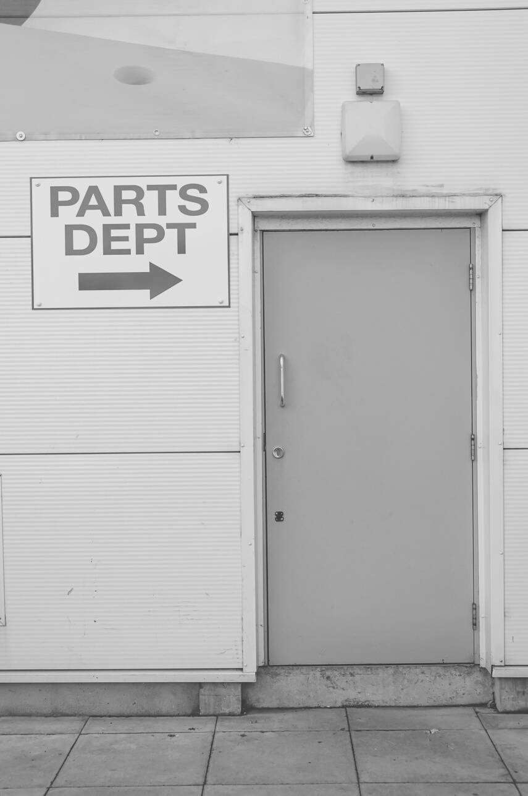

INSERT LOGO HERE.

* + BI-WEEKLY/MONTHLY Parts check and refills by INSERT DEALERSHIP NAME HERE.
  + You are only invoiced for the part once it leaves the cabinet.
  + We work with you to make sure you have the right parts mix, right at your fingers, so you are never one part short of finishing a job.

The Parts you need, when you need them.

INVESTMENT TO GET STARTED IS ONLY $199

It wasn't long ago Mike, one of our longtime customers, was working on his INSERT SPECIFIC BRAND HERE and ran into an issue, he didn't have the part he needed to finish the job.

He came to us and we said let's make sure that never happens again.

In that moment, our parts on demand program was born.

We put a cabinet full of the parts you need, where you need them for when you need them. It's that easy.

PARTS ON DEMAND